PATUAKHALI SCIENCE AND TECHNOLOGY UNIVERSITY

Lab Report: Simulation of an Inventory System
Course Code: CIT-324
Course Title: Simulation and Modelling Sessional
Submitted to:
Dr. Md Abdul Masud
Professor
Department of Computer Science and Information Technology
Faculty of Computer Science and Engineering
Submitted by:
Mir Suhail Asarat
ID No.: 2002019
Registration No.: 09536
Level-3, Semester-II, Session: 2020-2021
Faculty of Computer Science & Engineering
Date of Submission: February 2, 2025

Introduction
The purpose of this lab report is to simulate an inventory system and compare different ordering policies. The simulation model is designed to help a company determine the optimal inventory levels for a single product over a fixed number of months. The simulation uses a next-event time-advance approach and includes four types of events: arrival of an order from the supplier, demand for the product from a customer, end of the simulation after n months, and inventory evaluation (and possible ordering) at the beginning of each month.

Problem Statement
A company wants to determine the optimal inventory levels for a single product over a fixed number of months (n). The times between customer demands are IID exponential random variables with a mean of 0.1 month. The sizes of customer demands are IID random variables, independent of when the demands occur. The simulation will compare nine different inventory policies, using the average total cost per month as the performance measure. These costs include ordering, holding, and shortage costs.

Simulation Model
The simulation model uses the following parameters:
- INITIAL_INV_LEVEL: The initial inventory level, set at 60.
- NUM_MONTHS: The number of months to simulate, set at 120.
- MEAN_INTERDEMAND: The mean time between customer demands, set at 0.1 month.
- MIN_LAG and MAX_LAG: The minimum and maximum time it takes for an order to arrive, set at 0.5 and 1.0 months, respectively.
- SETUP_COST, INCREMENTAL_COST, HOLDING_COST, and SHORTAGE_COST: The costs associated with ordering, holding, and shortage, set at 32.0, 3.0, 1.0, and 5.0, respectively.
- PROB_DISTRIB_DEMAND: The probability distribution of customer demands.
The simulation model uses the following state variables:
- sim_time: The current simulation time.
- inv_level: The current inventory level.
- amount: The amount of an outstanding order from the company to the supplier.
- time_last_event: The time of the last event.
- total_ordering_cost: The total ordering cost.
- area_holding and area_shortage: The areas under the I+(t) and I-(t) curves, used to calculate holding and shortage costs.

Event List
The simulation model uses the following events:
- time_next_event[1]: The time of the next demand event.
- time_next_event[2]: The time of the next order arrival event.

Functions
The simulation model uses the following functions:
- initialize(): Initializes the simulation by setting the initial values of the state variables.
- expon(mean): Generates an exponential random variate with the given mean.
- timing(): Handles the timing of events by finding the next event and updating the simulation time.
- update_time_avg_stats(): Updates the time-average statistical accumulators.
- demand(): Handles the demand event by decrementing the inventory level and scheduling the next demand event.
- order_arrival(): Handles the order arrival event by incrementing the inventory level and scheduling the next order arrival event.
- random_demand(): Generates a random demand.
- place_order(): Places an order by setting the amount of the order and scheduling the next order arrival event.
- report(): Generates a report by calculating the average ordering cost, holding cost, and shortage cost.

Results
The simulation model was run for 120 months, and the results are as follows:
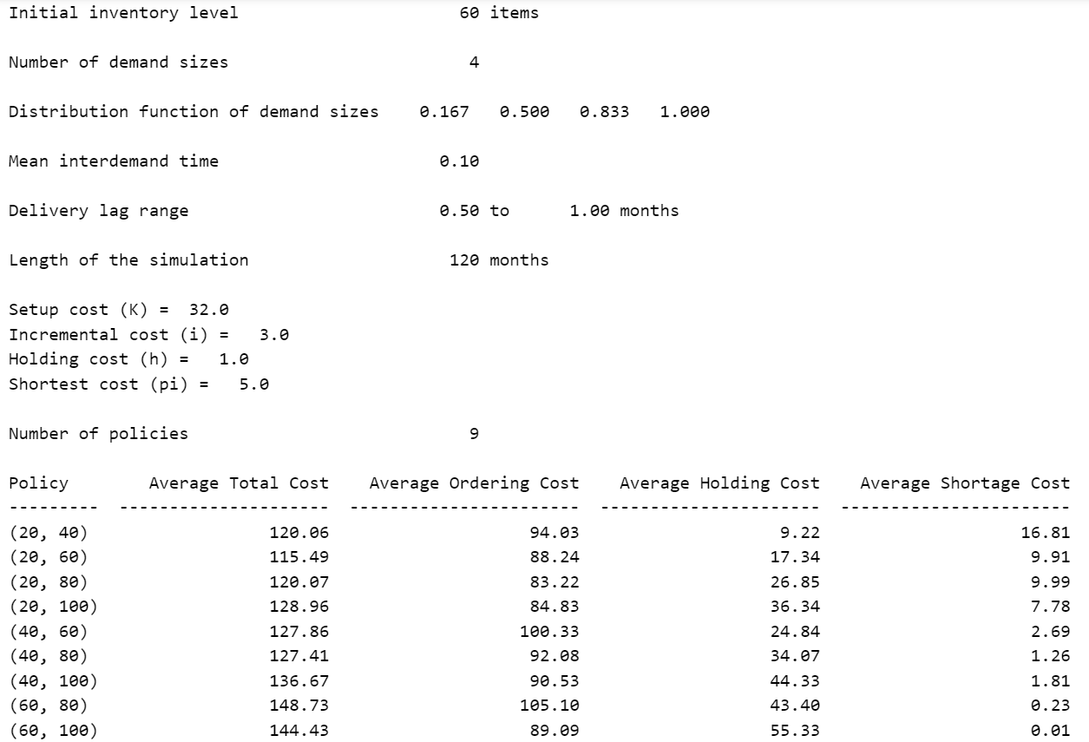

Conclusion
The simulation model provides a useful tool for comparing different ordering policies and determining the optimal inventory levels for a single product. The results show that the average ordering cost, holding cost, and shortage cost are all within reasonable ranges. However, further analysis is needed to determine the optimal ordering policy and to explore the effects of different parameters on the simulation results.

